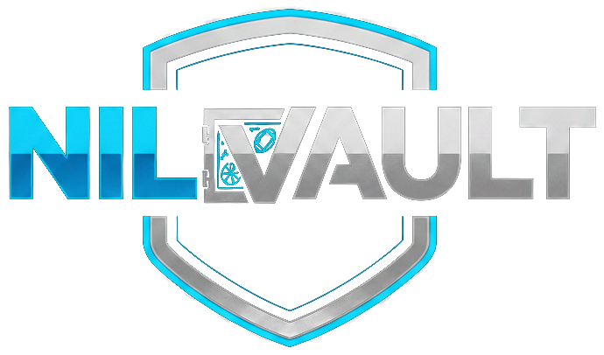 | THE COME UP  PARTICIPANT MEDIA CONSENT & RELEASE  For athlete stories, student-produced features and interviews
Complete this form before recording or submitting any content featuring the participant. For anyone under 18, both the participant and a parent or legal guardian must sign. This form contains private information; upload it only through the designated NILVault submission process and do not post it publicly.
1 | PARTICIPANT AND PRODUCTION DETAILS
Project or story title | Submission type  Athlete Story / Student Feature / Interview / Other
Participant legal name | Preferred public name
Email address | Phone number
Date of birth (MM/DD/YYYY) | Age on signing date
School, college or organization | Sport, team or role
Producer / submitter name | Recording date
Producer email | Submission location or event
2 | PERMISSION TO RECORD AND PUBLISH
□ I voluntarily consent to being photographed, filmed, audio-recorded and/or interviewed for this submission. [REQUIRED]
□ I authorize NILVault.app ("NILVault") to edit and publish my name, image, likeness, voice, interview, performance, quotes and approved biographical information in The Come Up and on NILVault-controlled websites, apps, podcasts, video channels, social media, email, press and program materials. [REQUIRED]
□ I authorize reasonable clips, still images, captions, thumbnails and excerpts to promote this specific story, episode and the Student Video Production & Submission Program. This does not authorize an unrelated third-party product endorsement. [REQUIRED]
□ OPTIONAL: NILVault may reuse approved excerpts in future educational compilations, training materials, highlight reels and program retrospectives.
3 | WHAT I UNDERSTAND
• Editing and format. NILVault may edit for length, clarity, captions, accessibility, graphics, formatting and platform requirements, but should not materially misrepresent what I said or did.
• License. The permission above is non-exclusive, worldwide, royalty-free and continuing for published materials, subject to the withdrawal provision below.
• No guaranteed publication. Submitting or recording content does not guarantee publication, a specific platform, an NIL opportunity, payment or a particular number of views.
• No payment unless separately agreed. This is a media consent and release, not an NIL sponsorship, endorsement or compensation agreement. Any payment must be covered by a separate written agreement.
• No final-edit approval. I will not automatically receive approval rights over the final edit, although NILVault may seek clarification or reconfirm sensitive facts.
• Withdrawal before publication. I may request withdrawal before publication through the contact method listed on NILVault.app. After publication or distribution, NILVault may be unable to remove every copy, repost, archive or third-party share.
• Accuracy and confidentiality. I will not knowingly provide false information or disclose confidential, private, medical, educational, contractual or financial information that I am not authorized to share.
• School and NIL requirements. I understand that I may need to follow school, conference, athletic-association, team, state or other disclosure rules. This form does not replace those requirements.
• Authorized-use release. To the extent permitted by law, I release NILVault and its authorized production partners from claims based on privacy, publicity or portrayal arising from uses specifically authorized by this form, but not from uses outside this permission.

THE COME UP | CONSENT & RELEASE | PAGE 2
4 | IDENTIFICATION, PRIVACY AND PARTICIPANT INSTRUCTIONS
□ NILVault may identify me by my preferred public name, school/organization, sport/team and role as listed on this form.
□ NILVault may tag or display the following public social handle(s): ______________________________________________
□ Please identify me only as follows: ______________________________________________________________________
□ Do not publish or display my personal email, phone number, date of birth, home address, student ID, private schedule, financial information or other private contact information. [REQUIRED]
Sensitive topics, safety concerns, accessibility needs or information that must not be published:
5 | PARTICIPANT SIGNATURE
By signing, I confirm that I have read this form, understand it, had the opportunity to ask questions and agree voluntarily. A typed signature is intended as my electronic signature when this form is completed electronically.
Participant signature / typed name | Date
Printed legal name | If under 18, participant assent signature
6 | PARENT OR LEGAL GUARDIAN CONSENT Required only when participant is under 18
I certify that I am the participant's parent or legal guardian and have authority to grant this permission. I have read and agree to the terms above on behalf of the minor, and I consent to the minor's participation and authorized use of the minor's name, image, likeness and voice.
Parent / guardian full legal name | Relationship to participant
Parent / guardian email | Parent / guardian phone
Parent / guardian signature / typed name | Date
7 | PRODUCER / SUBMITTER CERTIFICATION
I confirm that the participant had a reasonable opportunity to review and sign this form voluntarily before submission. I will keep the participant's private contact information out of the published content and submit this form only through the designated NILVault process.
Producer / submitter signature / typed name | Date
NILVAULT.APP | THE COME UP | PARTICIPANT MEDIA CONSENT & RELEASE
This form should be retained with the production records. Do not publish the completed form.

